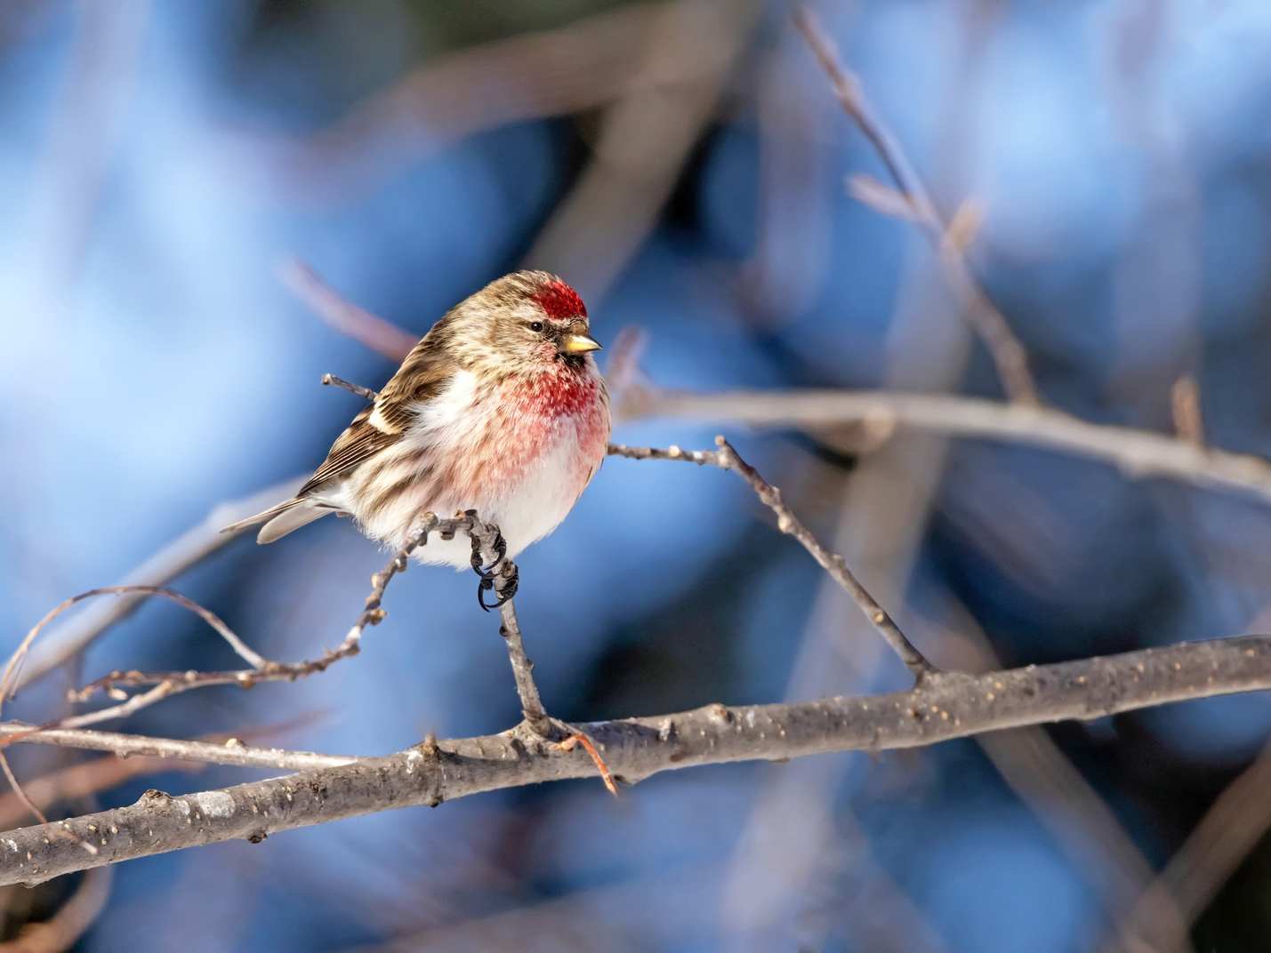
Image Credit: iStock.com/Dee Carpenter Photography

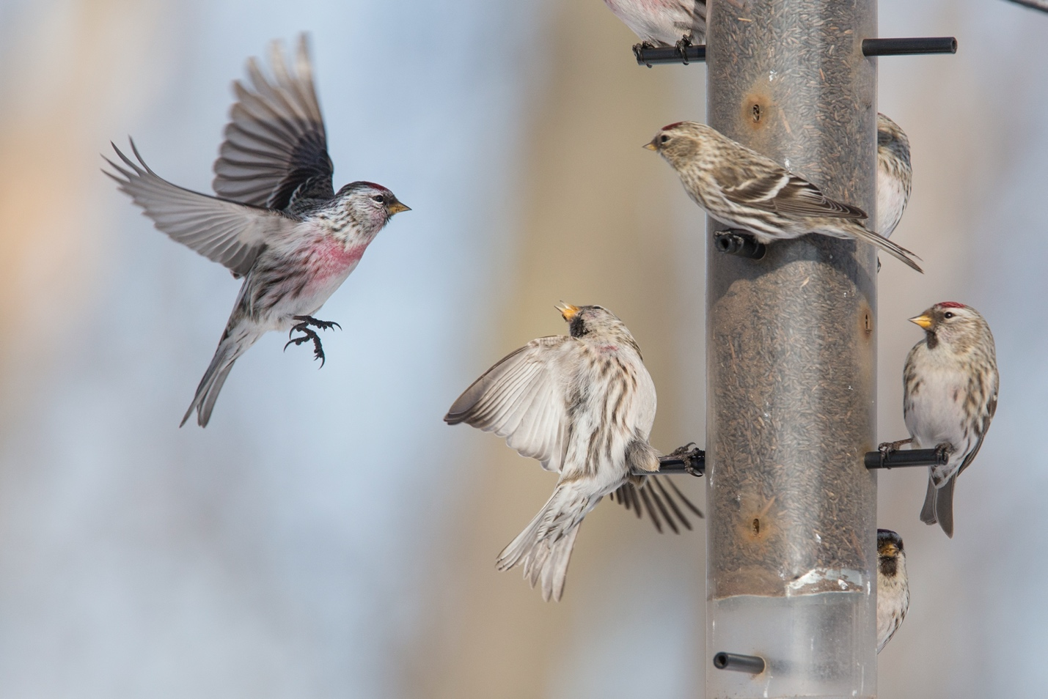
Image credit: iStock.com/micreax

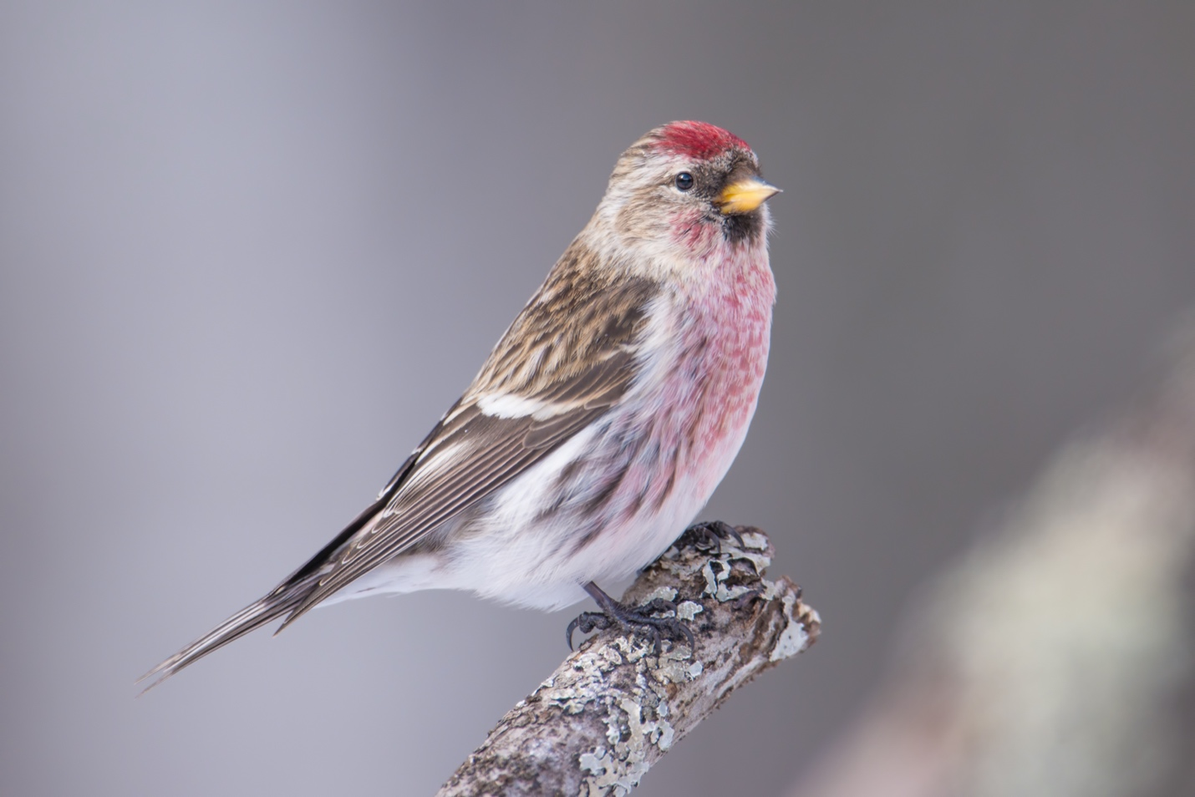
Image Credit: iStock.com/BobGrif

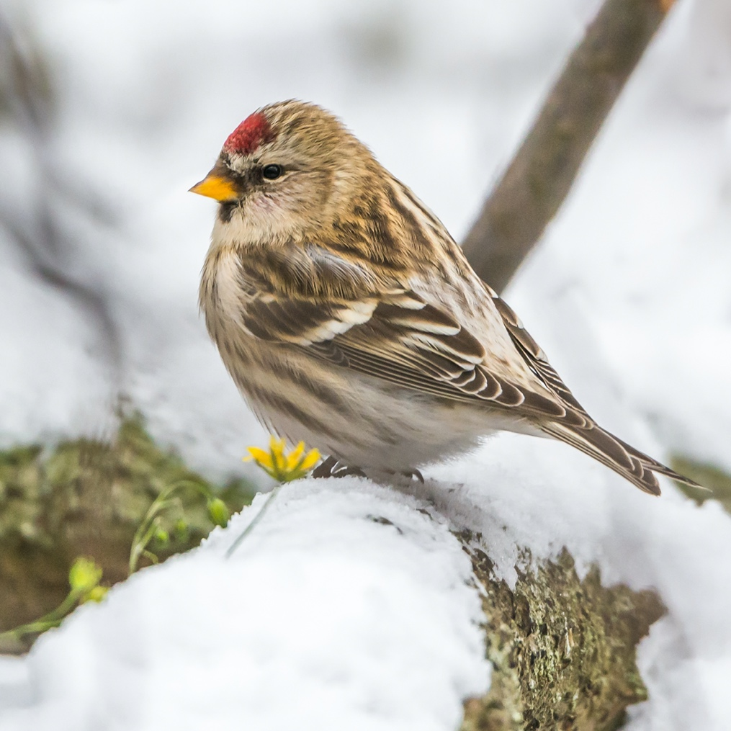
Image Credit: iStock.com/hannurama

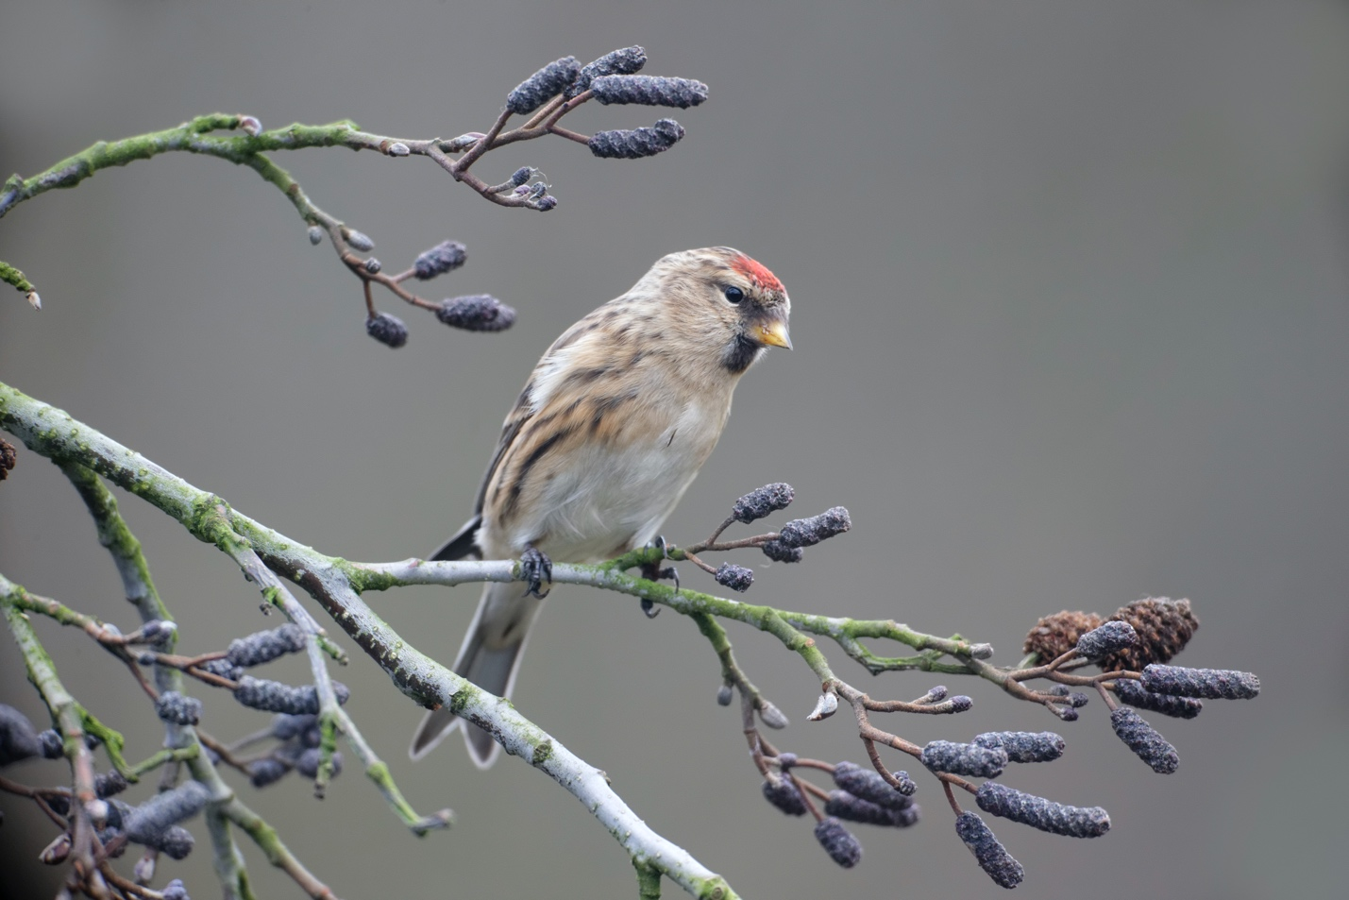
Image Credit: iStock.com/MikeLane45

